|  |  |  |  |  |  |
| --- | --- | --- | --- | --- | --- |
| Name: | _________________________________________________ | | | |  |
| Baldivis logo cropped | **Mathematics Applications Unit 3 & 4 Year 12**  **Investigation 1, 2018**  **Topic – Data Investigation In Class Component**  **30 Minutes Working time** | | | | |  | | --- | |  | | 20 | |
| **Equipment:** | *SCSA Formula sheets, CAS calculator, Take Home Component* | | | | |
|  | | | | | |
| **Date out:** | | *Week ____ Date ________* | **Date Due:** | *Week ____ Date __________* | |
| **Take home component weighting:** | | *0% of the year* | **In-class component weighting:** | *5% of the year* | |
| **Important Information:** | | | | | |

**Bivariate data analysis (3.1.1–3.1.19)**

Identifying and describing associations in categorical and numerical data – model and analyse associations using the framework of the data investigation process

**You will need to show FULL WORKING OUT to get full marks for a question**

**Question 1 [ 7 marks: 2,2,1,2]**

From the April 2017 weather data consider the Date and the Max Temperature data

1. Identify the response variable and the explanatory variable

Response ___________________________

Explanatory___________________________

1. What is the correlation coefficient and equation of the line of regression for this relationship?
2. Predict the temperature on April 31st using the equation
3. Comment on its reliability

**Question 2 [ 13 marks: 1,2,1,2,1,2,2,2]**

The World Health Organisation produces tables showing Child Growth Standards. The median lengths (cm) for girls at various times during the first five years of life are shown below.

|  |  |  |  |  |  |  |  |  |
| --- | --- | --- | --- | --- | --- | --- | --- | --- |
| **Age (months)** | 0 | 3 | 12 | 21 | 27 | 42 | 48 | 60 |
| **Median length (cm)** | 49.1 | 59.8 | 74.0 | 83.7 | 88.3 | 99.0 | 102.7 | 109.4 |
| **Predicted length (cm)** | 58.2 | 61.0 | 69.5 | 77.9 | ***A*** | 97.7 | ***B*** | 114.7 |
| **Residual** | –9.1 | –1.2 | 4.5 | 5.8 | 4.7 | 1.3 | ***C*** | ***D*** |

1. (i) Determine the equation of the least-squares line for predicting the median length from a girl’s age. (1 mark)
   1. Use the equation from (a)(i) to determine the predicted median lengths ***A*** and ***B*** in

the above table. (2 marks)

***A*** =

***B*** =

* 1. What increase in median length can be expected for each additional year?

(1 mark)

* 1. Given that the correlation coefficient is 0.97, describe the association between age and median length in terms of its direction and strength. (2 marks)
  2. What percentage of the variation in the median length can be explained by the variation in age(coefficient of determination)? (1 mark)

1. (i) Determine the residuals ***C*** and ***D*** in the table.

***C*** =

***D*** = (2 marks)

* 1. Hence, complete the scattergraph of the residuals against age on the axes below by plotting the last four residual values. (2 marks)

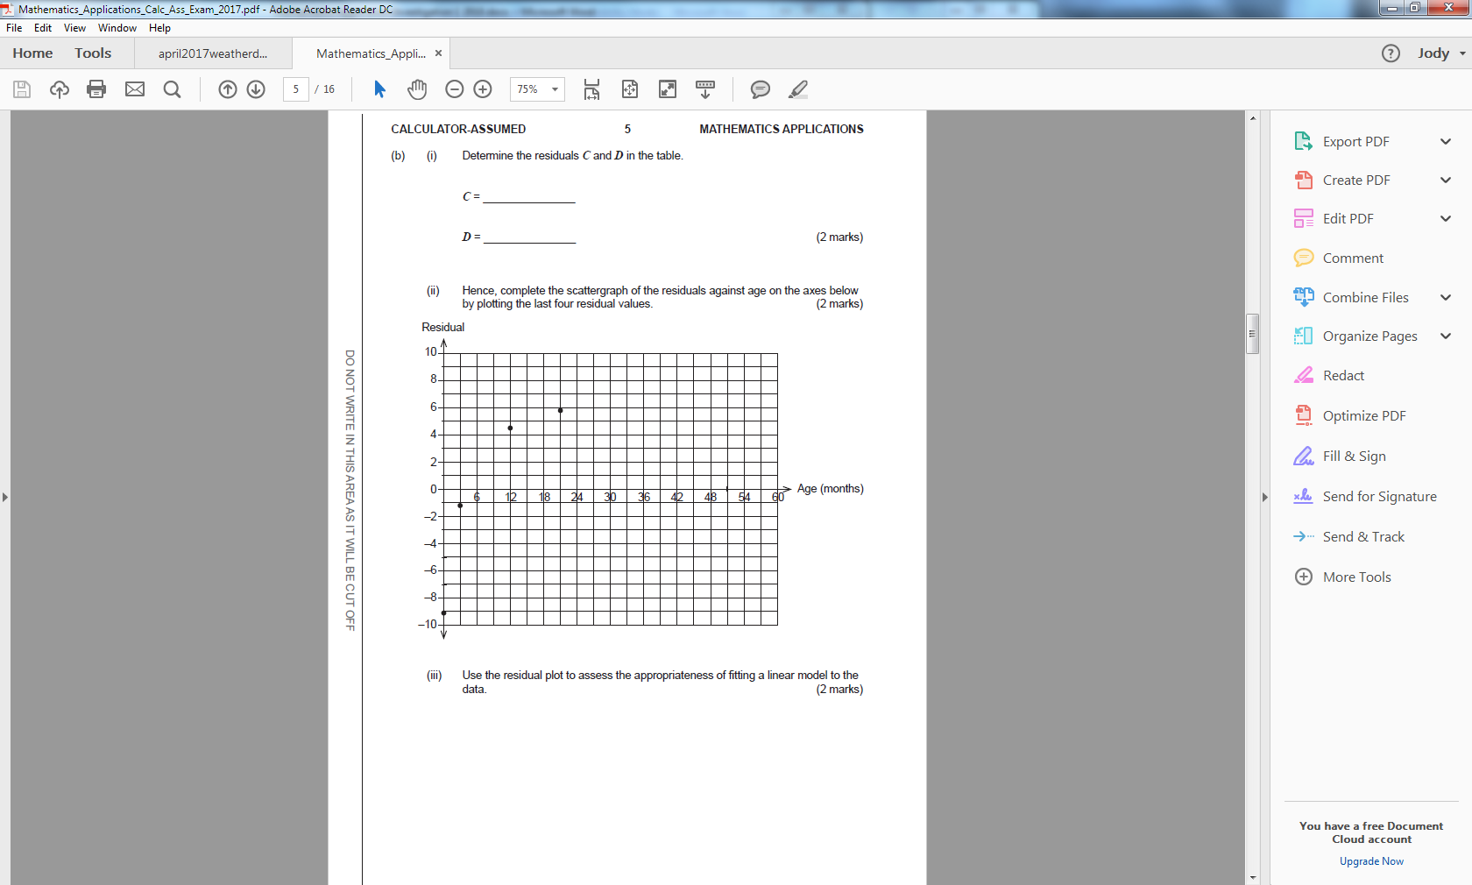

1. Use the residual plot to assess the appropriateness of fitting a linear model to the data. (2 marks)